# WRWorkRequest Dependencies

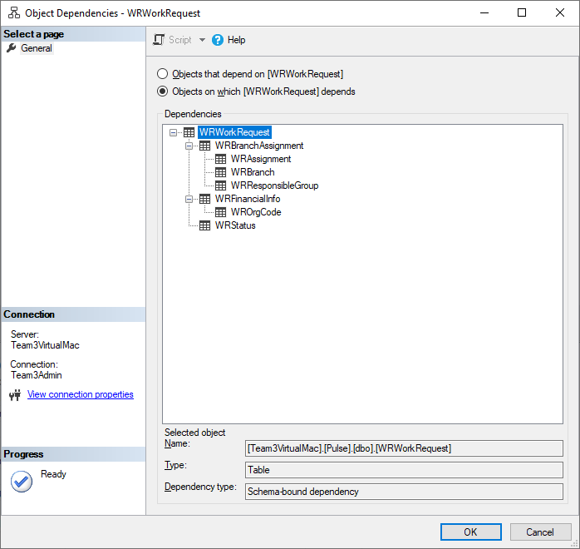

# WRProjectInfo Dependencies

